

SPARK: Simple Play Adaptations to Reference for Kids

Crayon Rocks
Description: | Image:
These safe, all-natural crayons are made of soybean wax tinted with natural mineral powders. Packed in a drawstring bag, this set contains 16 vibrantly colored crayons.  Purchasing Information | 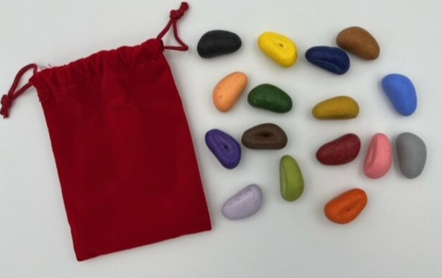

Who Might Benefit?
Those who…
• Demonstrate motor challenges and can’t hold a writing/drawing tool in the typical way.
• Have fine motor coordination challenges

Why Use?
Provides an opportunity to…
• Use stone-shaped crayons for developing and strengthening the grasps needed for handwriting.
• Draw, color, or create
• Create original artwork
• Mark on worksheets
• Color code
• Develop functional grasp for holding marking tools such as crayons, paintbrushes, pencils, etc.
Instructions for Use: | Adaptation Ideas:
Environmental Considerations  - Use in any environment with a hard surface to support the writing or drawing material.  Positioning  - Use in any position conducive to prewriting and writing activities (e.g. sitting at table, standing at easel, lying on tummy).  - Check table height. For children having trouble drawing or writing, it is possible that they are seated in a chair or at a table too high to provide the stability they need to control their crayons, pencils, or other marking tools. See Correct Sitting Posture for Kids from https://developlearngrow.com/.  Alternate Positioning  - Use with a slant board.  - Tape paper on an easel or vertical plane (wall, filing cabinet, refrigerator) to help refine grasp as well as help the child view what they are drawing.  Basic Play/Use  - Copy, draw, and create.  - Imitate prewriting strokes (lines, circle, cross, triangle, square.  - Create crayon rubbings.  Extended Play/Use  - Color sorting.  - Color matching.  - Color identification.  - Pattern activity.  - Color by number.  Play/Use with Others  - Sharing mat for 2 kids to share crayons.  - Shared drawing/coloring.  - One person creates a pattern and the other duplicates. | Optional Additional Materials/Supplies  - Slant board  - Easel  - Clip board  - Tape  Simplify It  Offer fewer color choices.  Contain it  - Place paper and crayons on cookie sheet or tray so that crayons remain close to the drawing activity.  Add Sensory Cues  - Place paper on top of a sheet of sandpaper for sensory feedback when drawing/writing.  Communication Support  - Social story to indicate how the crayons should be used for the intended activity (e.g. Story themes center around keeping the marker on the paper and not on table top or walls).  - Communication board with vocabulary appropriate for the writing or drawing activities presented (e.g. I’m finished, color selection vocabulary, help, more, etc.).  Alternative Uses  - Create crayon rubbings. Pace drawing paper over items such as leaves, paper clips, aluminum foil that has been flattened, then smoothed, etc. Rub crayon over the surface of the paper.  - Create a color matching game where child matches crayon rocks to color picture cards or color words, depending on their age and ability to recognize/read color words.  DIY Alternatives  - Make your own crayons shapes by melting crayons and pouring the melted wax into muffin tins, candy molds, empty glue stick containers, etc. See How to Make Recycled Crayons (Daniel Tiger’s Neighborhood).

Additional Considerations:
- Designed for ages 3-up.
- Supervise children who tend to put items in their mouth-these crayons look a little like giant jelly beans!

Resources:
- How to Make Recycled Crayons - If the child needs a special shape crayon due to challenges with grasp it is possible to recycle crayon and melt them into the needed shape and size.
- Video: Ms. G’s Story Time: How Is a Crayon Made?
- Video: The Day the Crayons Quit

Ohio Early Learning Standards:
- LL: Print Awareness: Develops understanding that writing represents spoken language (4.a.).
- LL: Emergent Writing: Draws and writes using increasingly sophisticated grasp (4.b.).

Words to Encourage Play/Use
Blue   | Red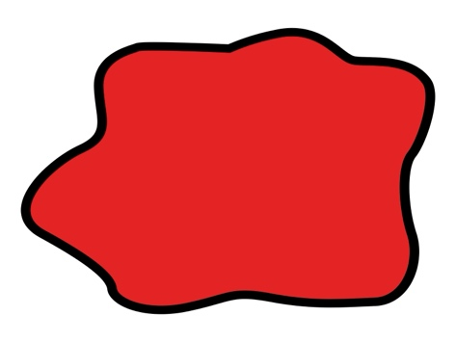 | Yellow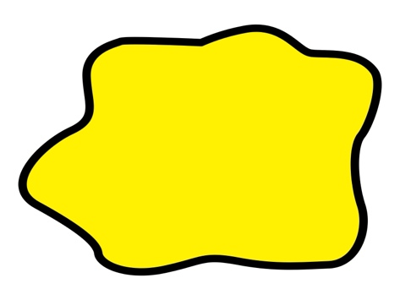
Green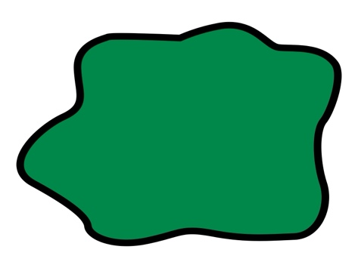 | Orange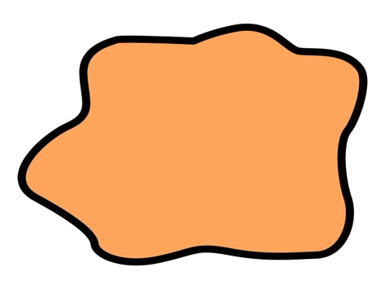 | Purple
Black | Draw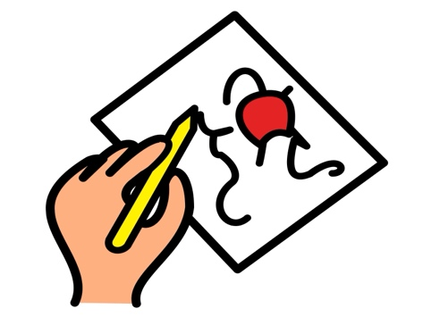 | Paper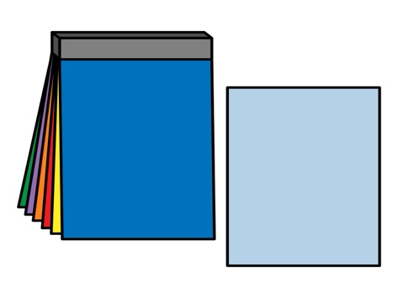
*”Adaptations” adapted from: Haugen’s Modes for Adapting Toys based on materials from the "Let's Play" Project at the University of Buffalo
PCS is a trademark of Tobii Dynavox, LLC. All rights reserved. Used with permission.

